Object oriented programming
LAB FILE

NAME – VANSH MADAAN
BATCH- B4
SAP_ID- 500123857
ROLL_NO - R2142230412
Experiment-2
1. Write a program to calculate the final grade of a student based on the marks entered in three subjects. Use the following grading scale:
Average >= 90: Grade A
Average >= 75: Grade B
Average >= 50: Grade C
Otherwise: Grade F
import java.util.Scanner; class StudentGrade { int OOP, SoftwareEng, DCN, LinearAlgebra, CloudCompFundamentals; public double average() {
return (this.OOP + this.SoftwareEng + this.DCN +
this.LinearAlgebra + this.CloudCompFundamentals) / 5.0;
}
public void printResult() { double average = average(); if (average >= 90) {
System.out.println("Grade: A");
} else if (average >= 75) {
System.out.println("Grade: B");
} else if (average >= 50) {
System.out.println("Grade: C");
} else {
System.out.println("Grade: F");
}
}
}
public class lab2_first { public static void main(String[] args) { Scanner sc = new Scanner(System.in);
StudentGrade s1 = new StudentGrade(); System.out.println("enter OOP marks:"); s1.OOP = sc.nextInt();
System.out.println("enter Software engineering marks:"); s1.SoftwareEng = sc.nextInt();
System.out.println("enter linear Algebra marks:"); s1.LinearAlgebra = sc.nextInt();
System.out.println("enter Data Communication and Networking
marks:"); s1.DCN = sc.nextInt();
System.out.println("enter Cloud Computing Fundamentals
marks:"); s1.CloudCompFundamentals = sc.nextInt(); s1.printResult();
}
}
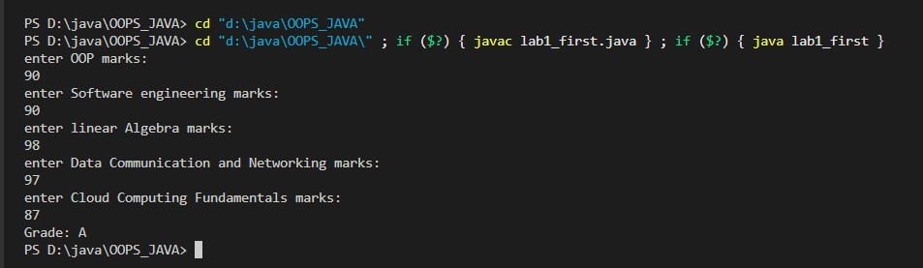
2. Print this Pattern:
1 2 3 4 5
1 2 3 4
1 2 3
1 2
1
=> public class lab2_second { public static void main(String[] args) { for (int i = 5; i >= 1; i--) { for (int j = 1; j <= i; j++) {
System.out.print(j + " ");
}
System.out.println();
}
}
}
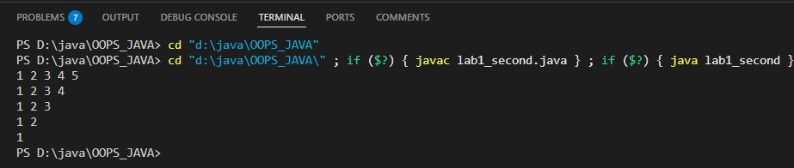
3. Create a program that accepts a number (1–7) and displays the corresponding day of the week using a switch statement.
=> import java.util.Scanner; class Shape { public double area(double length, double width) { return length * width;
}
public double area(double side) { return side * side;
}
public double area(double radius, boolean isCircle) { if (isCircle) { return 3.14 * radius * radius;
} else { return 0;
}
}
public double area(double base, double height, boolean isTriangle) { if (isTriangle) { return 0.5 * base * height;
}
return 0;
}
}
public class lab2_fourth {
public static void main(String[] args) { Scanner sc = new Scanner(System.in);
Shape shape = new Shape();
System.out.println("Choose a shape to calculate the area:");
System.out.println("1. Rectangle\n2. Square\n3. Circle\n4.
Triangle"); int choice = sc.nextInt(); switch (choice) { case 1: // Rectangle
System.out.print("Enter the length of the rectangle: "); double length = sc.nextDouble();
System.out.print("Enter the width of the rectangle: "); double width = sc.nextDouble();
System.out.println("Area of the rectangle: " +
shape.area(length, width));
break; case 2: // Square
System.out.print("Enter the side of the square: "); double side = sc.nextDouble();
System.out.println("Area of the square: " +
shape.area(side));
break; case 3: // Circle
System.out.print("Enter the radius of the circle: "); double radius = sc.nextDouble();
System.out.println("Area of the circle: " +
shape.area(radius, true));
break; case 4: // Triangle
System.out.print("Enter the base of the triangle: "); double base = sc.nextDouble();
System.out.print("Enter the height of the triangle: "); double height = sc.nextDouble();
System.out.println("Area of the triangle: " +
shape.area(base, height, true));
break default:
System.out.println("Invalid choice! Please choose a valid
shape.");
}
sc.close();
}
}
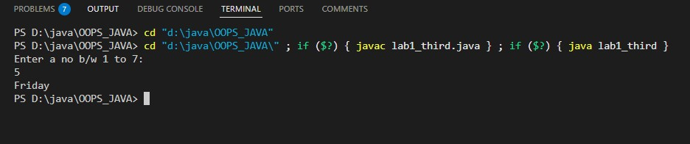
4. Write a program to find the area of a shape (Rectangle, Square, Circle, Triangle) using method overloading.
import java.util.Scanner; class Shape { public double area(double length, double width) { return length * width;
}
public double area(double side) { return side * side;
}
public double area(double radius, boolean isCircle) { if (isCircle) { return 3.14 * radius * radius;
} else { return 0;
}
}
public double area(double base, double height, boolean isTriangle) { if (isTriangle) { return 0.5 * base * height;
}
return 0;
}
}
public class lab1_fourth { public static void main(String[] args) { Scanner sc = new Scanner(System.in);
Shape shape = new Shape();
System.out.println("Choose a shape to calculate the area:");
System.out.println("1. Rectangle\n2. Square\n3. Circle\n4.
Triangle"); int choice = sc.nextInt(); switch (choice) { case 1: // Rectangle
System.out.print("Enter the length of the rectangle: "); double length = sc.nextDouble();
System.out.print("Enter the width of the rectangle: "); double width = sc.nextDouble();
System.out.println("Area of the rectangle: " +
shape.area(length, width));
break; case 2: // Square
System.out.print("Enter the side of the square: "); double side = sc.nextDouble();
System.out.println("Area of the square: " +
shape.area(side));
break; case 3: // Circle
System.out.print("Enter the radius of the circle: ");
double radius = sc.nextDouble();
System.out.println("Area of the circle: " +
shape.area(radius, true));
break;
case 4: // Triangle
System.out.print("Enter the base of the triangle: "); double base = sc.nextDouble();
System.out.print("Enter the height of the triangle: "); double height = sc.nextDouble();
System.out.println("Area of the triangle: " +
shape.area(base, height, true));
break; default:
System.out.println("Invalid choice! Please choose a valid
shape.");
}
sc.close();
}
}
